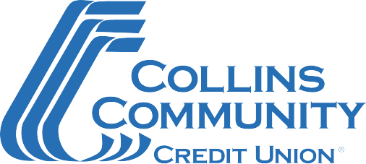

SBA First Round Paycheck Protection Program Document Checklist

Please complete the SBA Paycheck Protection Program Application Form and gather the supporting documentation listed below.
If you have any questions or are ready to submit your application, call 319-393-9000 Ext 2000. Our team is committed to serving you!

Document Checklist
- Completed SBA Paycheck Protection Program Application Form
  - For your first Paycheck Protection Program (PPP) loan, please complete form titled “SBA Form 2483: Borrow Application Form (March 2021)”.
- 2019 IRS Quarterly 940, 941 or 944 Payroll Tax Reports
- Payroll reports for a 12 month period (ending on your most recent payroll date), which will show the following information:
  - Gross wages for each employee, including officer(s) if paid W-2 wages
  - Paid time off for each employee
  - Vacation pay for each employee
  - Family medical leave pay for each employee
  - State and local taxes assessed on an employee’s compensation
- Documentation showing total of all health insurance premiums paid by the company owner(s) under a group health plan
- Document the sum of all retirement plan funding that was paid by the company owner(s) (do not include funding that comes from employees out of their paycheck deferrals).
  - Include all employees and the company owners
  - Include 401K plans, Simple IRA, SEP IRA’s

Revised – 03/2021

