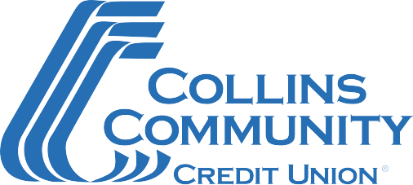

SBA First Round PPP-Schedule C Document Checklist

Please complete the SBA Paycheck Protection Program Application Form and gather the supporting documentation listed below.
If you have any questions or are ready to submit your application, call 319-393-9000 Ext 2000. Our team is committed to serving you!

Document Checklist
- Completed SBA Paycheck Protection Program Application Form
  - For your first Paycheck Protection Program (PPP) loan, please complete form titled “SBA Form 2483-C: Borrower Application Form for Schedule C Filers Using Gross Income (March 2021)”.
- 2019 or 2020 IRS Form 1040 Schedule C as included in your personal tax return

Revised – 02/2021

