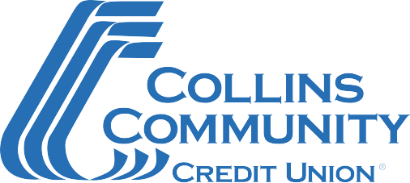

SBA Second Round Paycheck Protection Program Document Checklist

Please complete the SBA Paycheck Protection Program Application Form and gather the supporting documentation listed below.
If you have any questions or are ready to submit your application, call 319-393-9000 Ext 2000. Our team is committed to serving you!

Document Checklist
- Completed SBA Paycheck Protection Program Application Form
  - For your second Paycheck Protection Program (PPP) loan, please complete form titled “SBA Form 2483-SD: Second Draw Borrower Application Form (March 2021)”.
- 2019 filed tax returns, verifying reduction in gross annual receipts (see eligibility restriction below).
  - For independent contractors, please provide 2019 Form 1099.
- 2020 tax returns and/or tax forms (if available) verifying reduction in gross annual receipts
  - For independent contractors, please provide 2020 Form 1099.
- Completed annual (twelve-month) profit and loss statement for 2020.
  - Please sign and date the first page, and initial all subsequent pages.
  - Please separate data by quarter.

Restrictions
- Borrower is eligible for a Second Draw PPP Loan only if it has 300 or fewer employees.
- Second Draw PPP Loan may only be made to an eligible borrower that:
  - has received a First Draw PPP Loan, and
  - has used, or will use, the full amount of the First Draw PPP Loan on or before the expected date on which the Second Draw PPP Loan is disbursed to the borrower.
- To be eligible for a Second Draw PPP Loan, the borrower must have experienced a revenue reduction of 25% or greater in 2020 relative to 2019.

Revised – 03/2021

