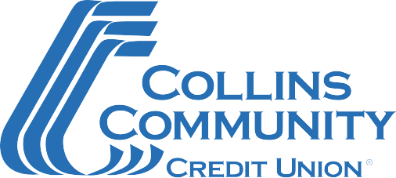

SBA Second Round-Schedule C PPP Document Checklist

Please complete the SBA Paycheck Protection Program Application Form and gather the supporting documentation listed below.
If you have any questions or are ready to submit your application, call 319-393-9000 Ext 2000. Our team is committed to serving you!

Document Checklist
- Completed SBA Paycheck Protection Program Application Form
  - For your second Paycheck Protection Program (PPP) loan using Schedule C gross income, please complete form titled “SBA Form 2483-SD-C: Second Draw Borrower Application Form for Schedule C Filers Using Gross Income (March 2021)”.
- 2019 or 2020 IRS Form 1040 Schedule C as included in your personal tax return
- Completed annual (twelve-month) profit and loss statement for 2019 and 2020 verifying reduction in gross receipts.
  - Please separate data by quarter.
  - Please sign and date the first page, and initial all subsequent pages.

Restrictions
- Borrower is eligible for a Second Draw PPP Loan only if it has 300 or fewer employees.
- Second Draw PPP Loan may only be made to an eligible borrower that:
  - has received a First Draw PPP Loan, and
  - has used, or will use, the full amount of the First Draw PPP Loan on or before the expected date on which the Second Draw PPP Loan is disbursed to the borrower.
- To be eligible for a Second Draw PPP Loan, the borrower must have experienced a revenue reduction of 25% or greater in 2020 relative to 2019.

Revised – 03/2021

